Working with HDF5 Files in Python

**The General Structure of an HDF5 file.**

HDF5 files use a “file directory” like structure. The typical HDF5 file would consist of groups and datasets.

* Groups – These are like folders in a file directory – they can contain other folders, or the datasets.
* Datasets – These correspond to the actual data in an HDF5 file. They can be any kind of data, including but not limited to things like Python Lists, Python Dictionaries, Numpy arrays etc.

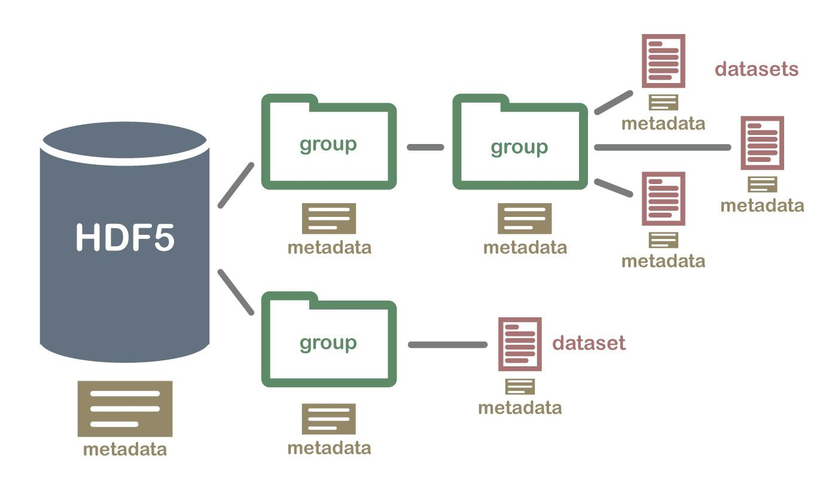

Picture Credit - [Hierarchical Data Formats - What is HDF5? | NSF NEON | Open Data to Understand our Ecosystems (neonscience.org)](https://www.neonscience.org/resources/learning-hub/tutorials/about-hdf5)

**H5PY**

H5PY is the package python uses to interact with HDF5 files. It is very similar to Pythons own file I/O.

You begin by installing and importing h5py, a simple “conda install h5py” should work to install it.

Opening an HDF5 file is simple.

with h5py.File(read_from, 'r+') as f:

Within this block of code, you have access the file whose name stored in “read_from” and it can be referred to as “**f”**.

To get a particular dataset from **f** is very simple as well – although you need to know what group it would be in.

Consider the example where the dataset **data** is in the group **group**. To access the dataset, you need only do the following –

i = “group/data”

temp = f.get(i)[:]

The variable **temp** now contains whatever data was stored in the dataset named “**data”,** which itself was stored in the group “**group”.** Of course, this is from the file referred to by the variable **read_from**.

What you do with the data now will depend on what kind of data it is.

An additional way to obtain datasets from a file is to loop through them. Here is an example of looping through an HDF5 file with several datasets. Each iteration of the loop, **“i”** will correspond to one of the datasets in the file whose name is stored in the variable “**read_from**”.

with h5py.File(read_from, 'r+') as f:  
  
 for i in f:

**I’d suggest using official documentation if needed as well.**

**The File obtained from Spike2_to_HDF5.py**

This is the first of many HDF5 files we work with. This file is created from Spike2 data files run through Spike2_to_HDF5.py. The structure of this file is simple, there are no groups, just datasets.

To elaborate, the datasets each refer to one of the channels obtained from the spike2 data, so the number of datasets will depend on the number of channels in this file. The name of the datasets are simply the names of the channels.

For example, say there are spike2 files with the channels “Sniff”, “Respirat”, LFP1, “LFP2”, “U1_2LFP”, “RefBrain”, “RefScrew”, “U1”, “U2” and “U3”. Then the dataset named “Sniff” will have the data from the channel “Sniff”, the dataset “Respirat” will have the data from the channel “Respirat” and so on.

Additionally, the dataset “Events” will have an array consisting of names and timing of the Odors. There will be additional datasets if you choose to enter them as well - “RatID”, “ExperimentName”, “ExperimentalGroup”, “Date”, “Name”.

**The File obtained from Channel_Extract.py**

While this file is an HDF5 file that contains data from multiple channels, it does so in a single dataset. This is because Spyking-Circus only expects a single dataset.

The dataset will always be named “unit”, and it is a 2D numpy array. Each row will be one of the channels of data. If you were to extract the channels “U1”, “U2” and “U3” for example, row 1 of the dataset would be data from “U1”, row 2 would be “U2”, and row 3 would be “U3”.

**The Spyking-Circus Files**

Upon running Spyking-Circus, it will generate several HDF5 files. The HDF5 file we’re interested in will end in result-merged.hdf5. An example of this would be the file named -

**U1, U2, U3 combined - ParameterTest_OE8_091119_Preinfusion and ParameterTest_OE8_091119_Postinfusion.result-merged.hdf5**

**File Structure:**

**I’d suggest reading spyking-circus’s own documentation of this file. It’s under the Fitting heading.**

[Generated Files — SpyKING CIRCUS 1.0.1 documentation (spyking-circus.readthedocs.io)](https://spyking-circus.readthedocs.io/en/latest/advanced/files.html)

But to summarize, we are interested in the **spiketimes** group, which contains datasets under the name **temp_i**, where the **i** is a number signaling a particular neuron.

For example, in a situation where 3 neurons were detected, there would be 3 datasets under the **spiketimes** group, named **temp_0, temp_1, temp_2**. Each of these datasets is a regular list of times where spikes were detected.

**However, there is something to note about the data from Spyking-Circus – the times are not saved in seconds. In order to obtain it in seconds, you will need to divide the dataset by the sampling rate of the data. In the below example, the variable period refers to 1/sampling rate.**

If you’re looking to figure out how many datasets are there and how to access them, here is some reference code –

with h5py.File(val, 'r+') as f:  
 length = len(f.get('spiketimes'))  
 for i in range(0, length):  
 string = "temp_" + str(i)  
 string = 'spiketimes/' + string  
 spiketimes = f.get(string)[:] * period

In this example, the variable **length** now refers to the size of the ‘**spiketimes**’ group.

The rest of the code is merely one of the ways to obtain the data from the datasets.

**The File obtained from EventSpikeMerger.py**

The python file EventSpikeMerger creates an HDF5 file as well. However, in this case due to the relative simplicity, there are no groups, there are only datasets.

The first three datasets are known as **Odor_Names, Odor_Onsets and Odor_Offsets.**

* Odor_Names is a python list of the order in which the odors were used.
* Odor_Onsets is a python list of the times at which the odor was released into the box.
* Odor_Offsets is a python list of times at which the odor was removed from the box.

These 3 Lists will have the same number of elements as each other, and put together, they will show you the name of the odor introduced, the time it was introduced at, and when it was removed.

Additionally, there are more datasets as well, lifted from the previous file. These are the **spiketimes/temp_i** datasets, but they are renamed to **neuron_i** in this HDF5 File. **Additionally, unlike the Spyking-circus data, this format of this data is in seconds.**

As previously described, each of these are from a neuron detected in spyking circus, so the number of these datasets depends on the number of neurons detected.

Each of these is a list of times at which spikes were detected, so this HDF5 files consists of odor information and spike timings, if I were to summarize.